# Lesson 03 – jQuery methods

# Session 1 Worksheet

# Exercise 1:

Using Netbeans, create a project called C273_L03ShipCostCalcApp. Follow the instructions of Bootstrap with Font Awesome and jQuery web template (offline) in the document **Web templates with jQuery.docx** in LEO C273 “Resources” Learning Path to create a new HTML file named exercise1.html. Change the code to the following.

|  |  |
| --- | --- |
| **1**  **2**  **3**  **4**  **5**  **6**  **7**  **8**  **9**  **10**  **11**  **12**  **13**  **14**  **15**  **16**  **17**  **18**  **19**  **20**  **21**  **22** | <!DOCTYPE html>  <html>  <head>  <title>Exercise 1</title>  <meta charset="UTF-8">  <script src="https://ajax.googleapis.com/ajax/libs/jquery/3.5.1/jquery.min.js"></script>  <script>  $(document).ready(function () {  var favText = $(".smallText").html();  var fruit = $(":text").val();  var message = favText + " " + fruit;  $("#result").html(message);  })  </script>  </head>  <body>  <p class="smallText">My favourite fruit is</p>  <input type="text" name="fruit" value="apple"/>  <p id="result"></p>  </body>  </html> |

Line 8 – All jQuery code is inside a document ready event. This is to prevent any jQuery code from running before the document is finished loading (is ready).

Line 9 – $(".smallText") retrieves the element of class “smallText”. html() method is used to retrieve the HTML contents of that selector and assigned to a JavaScript variable "favText".

Line 10 – $(":text") retrieves the input element of type “text”. val() method is used to retrieve the value of that form element and assigned to a JavaScript variable "fruit". <https://www.formget.com/jquery-get-value-of-input/>

Line 11 – "+" is used to concatenate the favText and fruit variables and is assigned to the third variable “message”.

Line 12 – $("#result ") retrieves the element of id “result”. html() method is used to set the content of that element with the value in variable “message”

Run it and the following will be displayed in the browser:

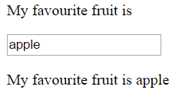

# Exercise 2:

Create exercise2.html and modify the jQuery code below to display the contents within the <p id=result> tag upon page load.

|  |  |
| --- | --- |
| **1**  **2**  **3**  **4**  **5**  **6**  **7**  **8**  **9**  **10**  **11**  **12**  **13**  **14**  **15**  **16**  **17**  **18**  **19**  **20**  **21**  **22**  **23**  **24**  **25**  **26**  **27**  **28**  **29**  **30**  **31**  **32**  **33**  **34**  **35**  **36**  **37**  **38**  **39** | <!DOCTYPE html>  <html>  <head>  <title>Exercise 2</title>  <meta charset="UTF-8">  <script src="https://ajax.googleapis.com/ajax/libs/jquery/3.4.1/jquery.min.js"></script>  <script>  $(document).ready(function () {  var email = $("[name=email]").val();  var qty = $("[name=qty]").val();  var bookName = $("select").val();  var payment = $(":radio:checked").val();  var message = "";  message += $("[for=idEmail]").html() + " is " + email + " <br/>";  message += $("[for=idQty]").html() + " is " + qty + " <br/>";  message += $("[for=idBookName]").html() + " is " + bookName + " <br/>";  message += $("label:eq(3)").html() + " is " + payment + " <br/>";    })  </script>  </head>  <body>  <label for="idEmail">Email</label>:  <input type="email" name="email" id="idEmail" value="123456@rp.edu.sg">  <br/>  <label for="idQty">Quantity</label>:  <input type="number" name="qty" id="idQty" min="1" max="999" value="80">  <br/>  <label for="idBookName">Books to purchase</label>:  <select name="bookName" id="idBookName">  <option value=""></option>  <option value="linux" selected>Linux</option>  <option value="java">Java</option>  </select>  <br/>  <label>Payment Method</label>:  <input type="radio" name="payment" id="idVisa" value="visa" checked><label for="idVisa">Visa</label>  <input type="radio" name="payment" id="idMaster" value="master"><label for="idMaster">MasterCard</label>  <input type="radio" name="payment" id="idExpress" value="express"><label for="idExpress">American Express</label>  <p id="result"></p>  </body>  </html> |

It should look like this when the page is loaded.  
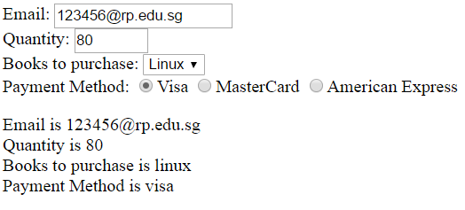



How about displaying the following output?

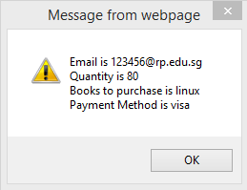

**Hint**: Use the JavaScript function alert()

**Exercise 3 (Bootstrap forms with jQuery):**

**Resource**: <https://getbootstrap.com/docs/4.5/components/forms/>

In Bootstrap, there are 3 form layouts: Vertical (default), inline and horizontal.

A basic Bootstrap form looks like this:

|  |  |
| --- | --- |
| **1**  **2**  **3**  **4**  **5**  **6**  **7**  **8**  **9**  **10**  **11** | <form method="post" action="submit.php">  <div class="form-group">  <label for="id_name">Name:</label>  <input type="text" name="myName" id="id_name" class="form-control"/>  </div>  <div class="form-group">  <label for="id_age">Age</label>  <input type="text" name="myAge" id="id_age" class="form-control"/>  </div>  <input class="btn btn-primary" type="submit" value="Calculate" />  </form> |

Lines 2, 3 - Wrap labels and controls in a <div> with the class **.form-group**. This is needed for optimum spacing.

Line 5 - Add a class of **.form-control** to all textual <input>, <textarea>, and <select> elements.

Create exercise3.html as below and add HTML code to your form to insert one more inline checkbox for Fanta($1.40). See <https://getbootstrap.com/docs/4.5/components/forms/#inline> and diagram below:

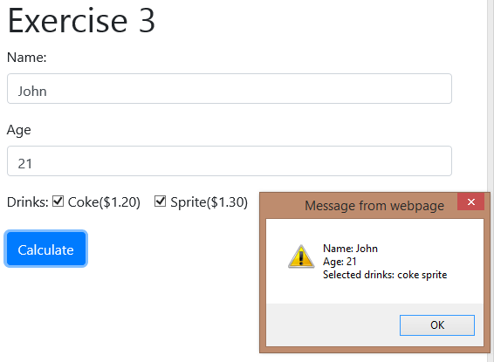

Diagram 3_1

|  |  |
| --- | --- |
| **1**  **2**  **3**  **4**  **5**  **6**  **7**  **8**  **9**  **10**  **11**  **12**  **13**  **14**  **15**  **16**  **17**  **18**  **19**  **20**  **21**  **22**  **23**  **24**  **25**  **26**  **27**  **28**  **29**  **30**  **31**  **32**  **33**  **34**  **35**  **36**  **37**  **38**  **39**  **40**  **41**  **42**  **43** | <!DOCTYPE html>  <html>  <head>  <title>Exercise 3</title>  <meta charset="UTF-8">  <meta name="viewport" content="width=device-width, initial-scale=1.0">  <link href="css/bootstrap.min.css" rel="stylesheet" type="text/css"/>  <script src="js/jquery-3.5.1.min.js" type="text/javascript"></script>  <script src="js/exercise3.js" type="text/javascript"></script>  </head>  <body>  <div class="container">  <h1>Exercise 3</h1>  <form method="post" action="#">  <div class="form-group">  <label for="id_name">Name:</label>  <input type="text" name="myName" id="id_name" class="form-control"/>  </div>  <div class="form-group">  <label for="id_age">Age</label>  <input type="text" name="myAge" id="id_age" class="form-control"/>  </div>  <div class="form-group">  <label for="id_coke">Drinks:</label>  <div class="form-check-inline">  <label class="form-check-label">  <input type="checkbox" id="id_coke" name="drinks[]" value="coke" class="form-check-input"/>Coke($1.20)  </label>  </div>  <div class="form-check-inline">  <label class="form-check-label">  <input type="checkbox" id="id_sprite" name="drinks[]" value="sprite" class="form-check-input"/>Sprite($1.30)  </label>  </div>    </div>  <input class="btn btn-primary" type="submit" value="Calculate" />  </form>  </div>  </body>  </html> |

Write the jQuery code to produce the output in Diagram 3_1 using the skeleton code given below.

**Hint:** Use the submit() event on the selector “form”,

Use the **each()** function to retrieve the values of the selected checkboxes. See <http://www.tutorialrepublic.com/faq/how-to-get-the-values-of-selected-checkboxes-in-a-group-using-jquery.php>

<https://webdevdoor.com/jquery/check-checkboxes-selected-form-submit>

|  |  |
| --- | --- |
| **1**  **2**  **3**  **4**  **5**  **6**  **7**  **8**  **9**  **10**  **11**  **12** | $(document).ready(function() {  $("form").submit(function() {  // complete the code here  $("[type=checkbox]:checked").each(function () {  // complete the code here  })  // complete the code here  return false;  })  }) |

Line 2 – The submit event occurs when a form is submitted. This event can only be used on <form> elements. See <http://www.w3schools.com/jquery/event_submit.asp>

Line 10 – The boolean value "false" is returned to stop a submit button from submitting a form.

Enhance your jQuery code to calculate the total cost of the selected drinks.

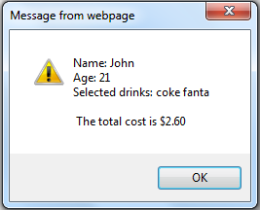

**Exercise 4**

Create moodyWedderBlog.php as follows.

|  |  |
| --- | --- |
| **1**  **2**  **3**  **4**  **5**  **6**  **7**  **8**  **9**  **10**  **11**  **12** | <!DOCTYPE html>  <html>  <head>  <title>TODO supply a title</title>  <meta charset="UTF-8">  <meta name="viewport" content="width=device-width, initial-scale=1.0">  <link href="css/bootstrap.min.css" rel="stylesheet" type="text/css"/>  <link href="css/all.min.css" rel="stylesheet" type="text/css"/>  <script src="js/jquery-3.5.1.min.js" type="text/javascript"></script>  <script src="js/moodyWedderBlog.js" type="text/javascript"></script>  </head>  <body >  <div class="container">  <h2>MoodyWedderBlog <i class="fa fa-sun"></i><i class="fa fa-tint"></i><i class="fa fa-snowflake"></i><i class="fa fa-bolt"></i></h2>  <div class="card border-info">  <div class="card-header bg-info text-white">Blog Entries</div>  <div class="card-body"></div>  </div>  <form id="blogform">  <div class="form-group">  <label for="name">Enter your name (optional):</label>  <input type="text" class="form-control" id="name">  </div>  <div class="form-group">  <textarea id="blog" rows="10" cols="20" class="form-control"></textarea>  </div>  <input type="submit" class="btn btn-info btn-block" value="Add a blog"/>  </form>  </div>  </body>  </html> |

It should look like this. Write the jQuery code to append the blog entries as they are added.

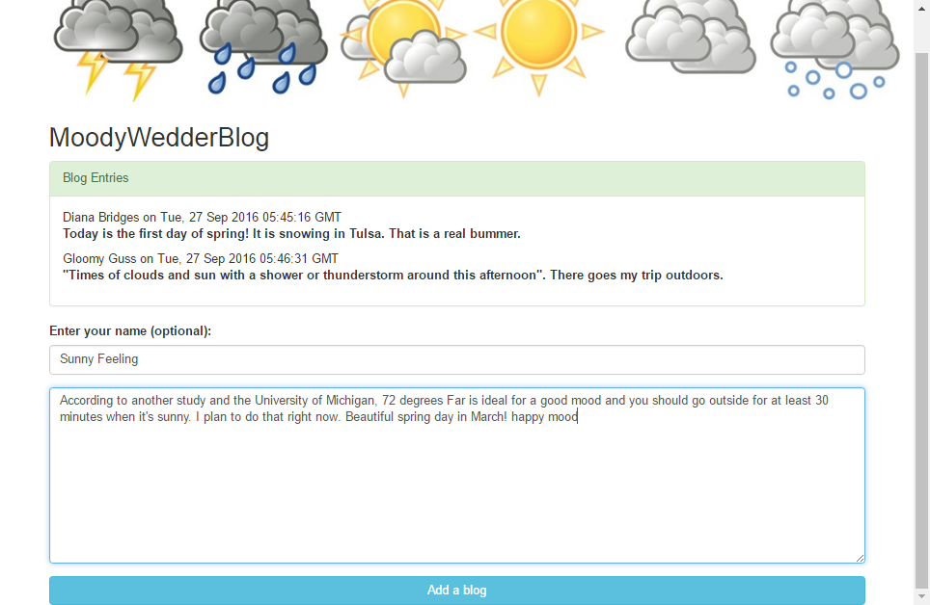

**Hint:**

* Use the submit() event on the selector “#blogform”,
  + Create a new Date() object to retrieve the current date time and assign to a variable “currDate”.
  + Use the val() method on the selector “#name” and “#blog” in order to retrieve the blogger’s name and entry.
  + Concatenate the blogger’s name and format the date string from “currDate” together with the blog entry and assign to another variable “message”.
  + Use the append() method on the selector “.card-body” to append the value of the “message” to it.
  + Reset the values of both selectors “#name” and “#blog” to empty strings
  + Prevent the form from submitting

# Submission

|  |  |
| --- | --- |
| **1**  **2**  **3**  **4**  **5**  **6** | $(document).ready(function () {  $("#blogform").submit(function (evt) {  // complete the code here  return false;  });  }); |